 | HOW TO EDIT YOUR LOSTWITHIEL U3A GROUPS WEB PAGE

1 Introduction

The Lostwithiel U3A website is divided into two parts:-

- The front end: the section with a picture of St Barts on the first page and a series of small pictures down the right hand side of other pages. This part can only be edited by the administrator. If you look in the bar at the top of your browser you will see this part of the website has an address similar to http://www.lostwithielu3a.org.uk/about.html

- The back end: the section with information about all the groups. This part of the web site will have an address similar to :- https://sites.google.com/site/lostwithielu3a/creative-writing We are using Google to host this part of the web site, which will allow Group Leaders to easily update their own pages.

2 How to edit your Group Web Page.

  - Google Mail accounts

Access to the edit mode on the website can only be given to people who hold a Google Account. These are free and there is no requirement to use it for anything other than editing the website. A Google account is activated by obtaining a gmail (or google mail) email account.

NOTE: A gmail account and a google mail account are the same, the two words are interchangeable. If you already hold a gmail account then jump to section 2.2 of these instructions.

To obtain a gmail account go to www.google.co.uk In the top right hand corner of the page you will see a button “Sign In”. Click this and you will then see another screen with a red button “Sign Up” Follow the instructions and obtain a gmail account. Once you have the new gmail account then send a brief message to lostwithielu3a@gmail.com saying which page(s) you would like to edit.

2.2 How to activate editing mode for website

Once you have a gmail account, and the website administrator is aware of your email address, you will be sent an automatically generated email inviting you to edit your pages on the website. To navigate to your page follow these instructions

a) Sign in to google at www.google.co.uk using your gmail email address.
b) Go to www.sites.google.com You will probably be asked to sign in again with you gmail email address and password.
c) once you have signed in you should see a screen with the following information in the middle of the screen:-

Lostwithiel and Area U3A Shared with everyone in the world
Details of the Groups forming part of Lostwitiel and Area U3A
/site/lostwithielu3a/

Click on Lostwithiel and Area U3A and you will be taken to the website. Navigate to the page(s) where you have editing privileges and you should see a display similar to the following:

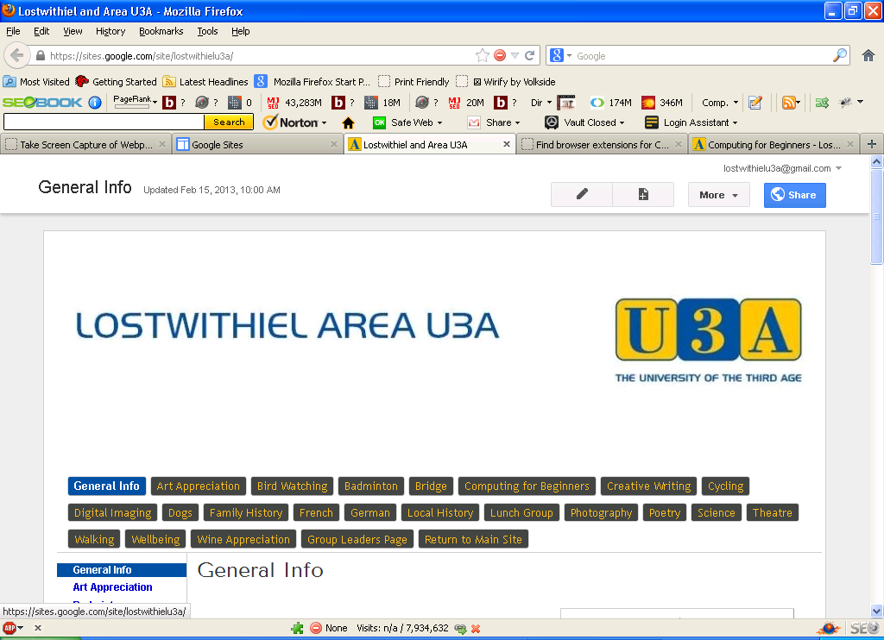

Click on the editing pencil (fourth box from the right at the top of the page).
The bar at the top of the page will then change, and look very much like the editing functions on any common word processor. You can then edit the page in the same way as you would edit any letter or report you may be preparing. When you have finished editing just click on the blue save button at the top right of the screen and you will have made the changes. That’s it !!

3. More Help

If you need help in editing the site there are lots of pages on the web. These are a couple of the more useful :-

https://sites.google.com/site/amslerclassroom/Home
https://sites.google.com/site/siteshelphowtos/google-sites-instructions

If you prefer to see a video then try:-

Brief video showing introduction to page editing :-
http://www.youtube.com/watch?v=kKbPmfobfq8&feature=youtu.be

More detailed video showing use of the Google sites tool bar :-
http://www.youtube.com/watch?v=_Y-OhihSw0U&feature=youtu.be

If you need any more help just give me a ring (01208 873371) or send an email to keithsouthgate@gmail.com

KS Version 3.0 16th March 2016

